Melle Dijkstra

Melle210202@gmail.com

14-12-2015

Description

This document is about the usage of the application/product and the maintenance to keep the site running

Usability & Management

Cheery

# Table of contents

1 Table of contents 1

2 Cheery Usability 2

3 Server Maintenance 3

3.1 Database Backup 3

# Cheery Usability

Because Cheery will be for everyone in any age it should be clear how to use the application. This is already done when realizing the product. The interface is thought about when realizing the project and should be easy to use. Some buttons with text that just says what it does.

The way you go through the application is quite simple and easy to understand. Here is a base of the functionality you can do on Cheery in a flow diagram:

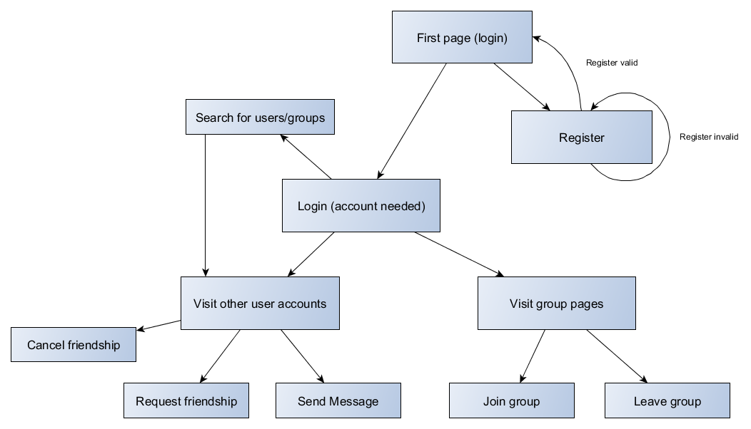The first thing that you can you do when visiting Cheery is login if there already is an account of yours or register a new account. When registered you can login as normal and then you are in the application and have a lot more functionality which you can do. Like visit other user/group pages and also make friends and join groups. Also searching for other users.

To make it as easy as possible for the users of Cheery, a whole icon set is used to show the functionality of a button or element on the page with a visual aspect.

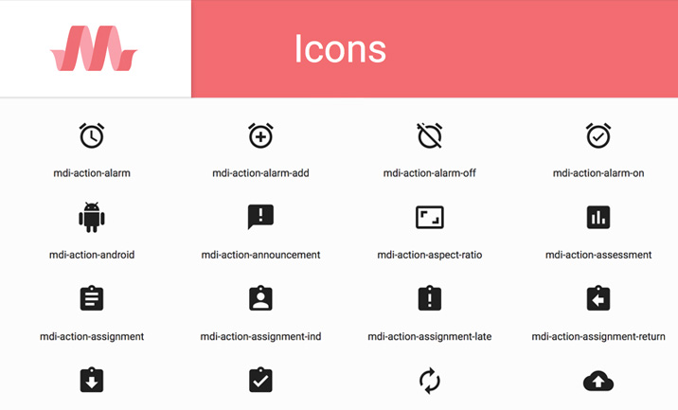

# Server Maintenance

## Database Backup

The database of cheery needs to be backed up often. The amount that it needs to be backed up and in how many times in a given time range depends on the traffic to the site. This could be automated by checking the database for the amount of changes. If it goes above a given amount then back up the database.

When backing up the database be sure that the whole database can be recovered at any time. The location where the Cheery database will be backed up should be secure so that no-one without authorization can find the data.

The procedure of backing up the database can be automated as I said above which can be done with running scripts that check when to backup or it can be done manual with phpMyAdmin of some sort of tool with exporting functionality.

## Server Check

Once in a while there should be a check if the server is still running fine. This can be done to simply SSH into the server with its IP and SSH protocol. When connected it should be check for CPU, RAM usage and also storage. When storage is getting full then this should be noted and upgraded immediately.

Below is described how to connect with SSH:

<https://www.digitalocean.com/community/tutorials/how-to-use-ssh-to-connect-to-a-remote-server-in-ubuntu>

